TopCoder Cockpit - Bug Race Project Contests View Deployment Guide

Revision History
Author | Revision Number | Date
TCSASSEMBER | 1.0 | 05/11/2012

Deployment Instructions 3
1. Organization of Submission 3
2. Application Setup 3
2.1 Ant .Properties File 3
2.2 Build Scripts Setup 3
3. Database Setup 4
4. Deployment Instructions 4
5. Starting 4
6. Verification 4
7. Resource Contact List 5

Deployment Instructions

Organization of Submission

The submission follows directory structure provided below:

doc
Contains the Deployment Guide Document of this assembly.

direct
Contains sources and static files for Direct web application. This directory replicates the application development distribution structure and includes only updated and new files.
test_files
Contains the SQL files to insert test data

Application Setup

The application is expected to be deployed to the following environment:

JRE 1.5
JBoss 4.2.3.GA
Informix DS 11.5

Ant .Properties File

No .properties files are modified.

Build Scripts Setup
The ANT build script for Direct application (build.xml) provides the following targets which are to be used:

- switch-and-checkout – checkout or switch to the defined source code branches for all components defined in subprojects.xml
- dist-backend – rebuilt all the components from the source code.
- first_deploy – must be the first task to execute from command line. It will copy all dependencies to your local JBoss folder.
- deploy – should be the main task to execute from command line. It will build and deploy WAR file.
- deploy-static-files – deploys the static files to JBOSS.
- deploy-apache-static – deploys the static files to apache server on VM.

Please refer here for more information:
http://www.topcoder.com/wiki/display/docs/TC+Direct+Setup+Guide

Configurations

Configure the following parameters in token.properties to suite your environment

Parameter name | Description | Sample
@jiraServiceEndPoint@ | The JIRA service end point | https://apps.topcoder.com/bugs/rpc/soap/jirasoapservice-v2
@jiraServiceAdminUserName@ | The username of the JIRA account | Your TopCoder username
@jiraServiceAdminUserPassword@ | The password of the JIRA account | Your TopCoder password
@jiraIssueURLPrefix@ | The prefix of JIRA issue URL | https://apps.topcoder.com/bugs/browse/
@jiraProfilePrefix@ | The prefix of JIRA profile URL | https://apps.topcoder.com/bugs/secure/ViewProfile.jspa?name=
@jiraBugRaceProject@ | The JIRA project name which holds the Bug Race issues.  Note: In production environment, this property must be BUGR. | TEST

Sample configuration in token.properties

############################
# objectFactory_config.xml #
############################
@jiraServiceEndPoint@=http://apps.topcoder.com/bugs/rpc/soap/jirasoapservice-v2
@jiraServiceAdminUserName@=<handle>
@jiraServiceAdminUserPassword@=<password>

############################
# IssueTrackingConfig.xml #
############################
@jiraIssueURLPrefix@=http://apps.topcoder.com/bugs/browse/
@jiraProfilePrefix@=http://apps.topcoder.com/bugs/secure/ViewProfile.jspa?name=
@jiraBugRaceProject@=TEST

Database Setup
- None

Deployment Instructions

If you test on VM provided by TopCoder, please import the correct SSL certificate first

- Upload test_files/topcoder.crt from the submission to /home/direct/ in VM.
- Login in VM as user "direct", stop the jboss instance: kill all java
- jbb
- cp TC.cloud.ldap.keystore new.TC.cloud.ldap.keystore
- keytool -import -file ~/topcoder.crt -keystore new.TC.cloud.ldap.keystore -alias topcoder_bug
- You will be required to provide password. The password is 'topcoder'.
- And input "yes" when asking "Trust this certificate?"
- Edit /home/direct/jboss/bin/run.conf, replace "TC.cloud.ldap.keystore" with "new.TC.cloud.ldap.keystore".

This section provides the instructions in Production environment.

- Merge the code from submission into SVN for Direct application
- Build and deploy Direct application using ant deploy (or ant first_deploy ) command.
- Copy static files using ant deploy-static-files command or ant deploy-apache-static if use apache as static file server.

Starting

- Build and deploy the Direct application
- Start JBoss server instance hosting Direct application

Verification

Set up test data first, run the following SQL scripts in order against the test server database:
- test_files/test-data.sql

Use various browsers to open the link http://localhost:8180/direct or https://[vm_ip]/direct/ , login as heffan / password.

Open the project overview page of Project: Client 1 Billing Account 1 Project 1

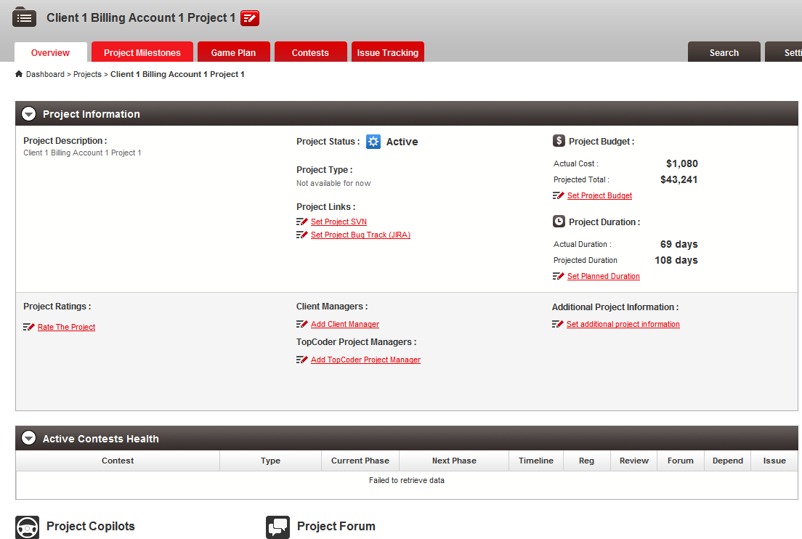

Open the contests tab

In the filter panel, choose contest type drop down

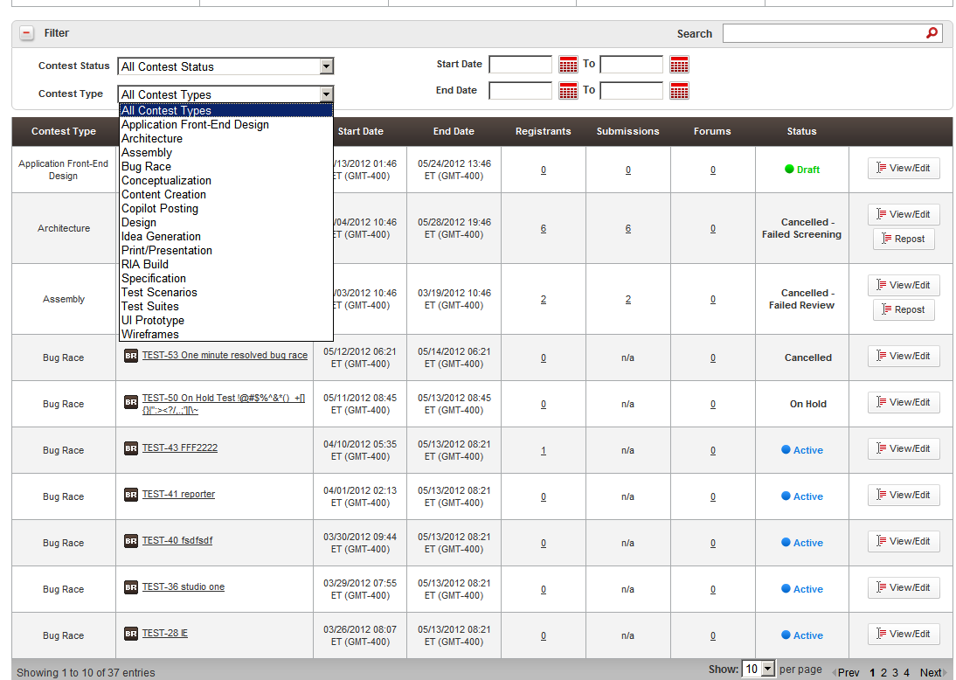

Choose Bug Race to filter

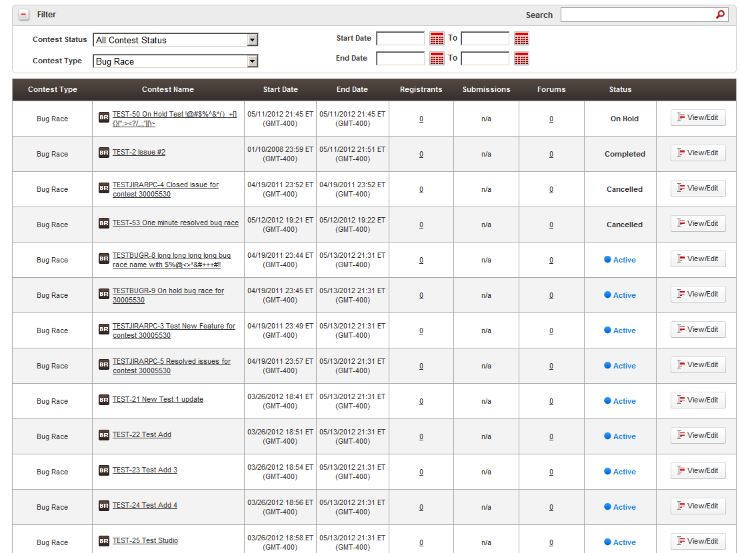

Open the calendar button on the right up



You will see

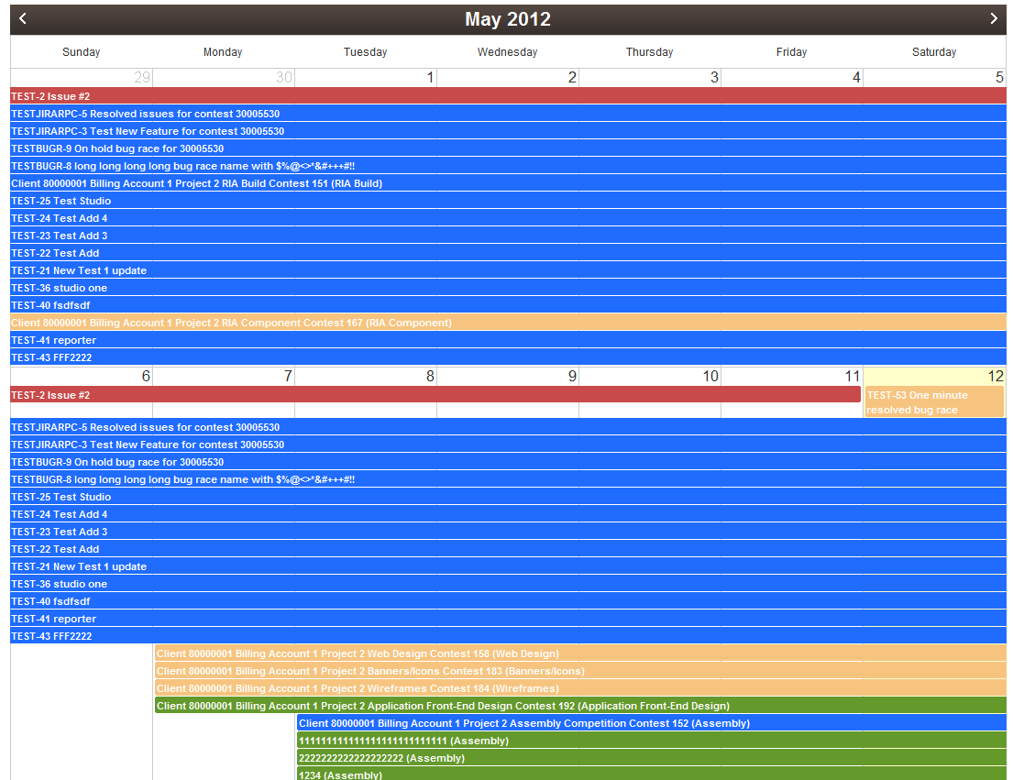

Click the game plan tab to view bug races in game plan

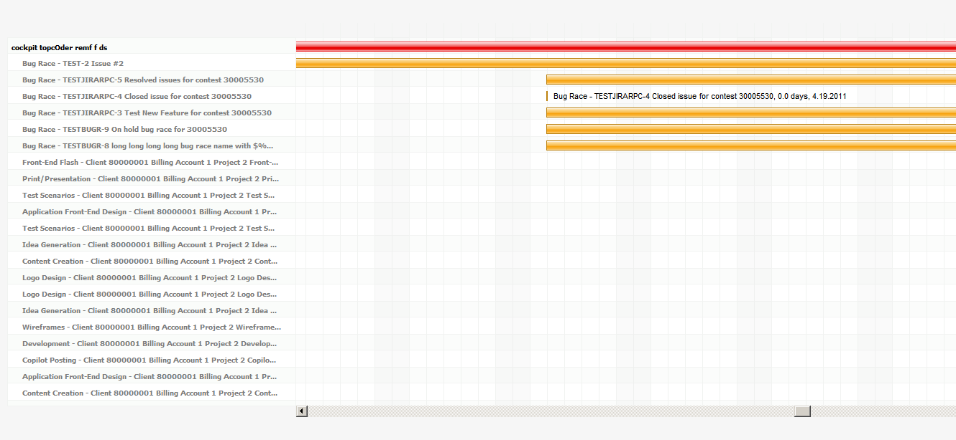

Click the bug race name will bring you to the bug race page

Resource Contact List

Name | Resource Email
TCSASSEMBLER

